**NIST COLLEGE**

Affiliated to Tribhuvan University



Project report of Web Technology

Topic: Apartment Rental Service

Submitted To:

Sanjog Sigdel

Nist College

Submitted By:

Anjana Khatri

Bishal Raut

Bimesh Shrestha

CSIT 5th sem

Submission Date:

**Apartment** **Rental service Website**

**Introduction**

The house rental issue is one of the elemental parts of society. Nowadays, it is extremely difficult to find suitable accommodation in city areas if people search for it physically. On the other hand, the land owner also needs to rent the house. It can be difficult to find tenants just to hang a lease sign on a building, and as a result, they lose money. This online common platform can play a vital role in this case. This web-based online platform helps for both tenants and house owners so that both tenants and landowners will mutually benefit from the system.

**Objective**

The main objective of our project is:

* to help the renters to find their home and apartments
* to help the rentals to advertise their apartments and homes for rents
* People can easily find best apartments and home at affordable rents with best facilities and good security through our website.

**Implementation methodology:**

We have prepared this website using html, CSS and bootstraps.

**HTML (Hyper Text Markup Language):**

It is the standard markup language for documents designed to be displayed in a web browser. It can be assisted by technologies such as cascading style sheets (CSS) and scripting languages such as JavaScript. Various html tags and elements are used in designing the web pages. Most common html tags used are: <html>,<head>,<title>,<body>,<h1>,<p>,<a>,<div>,<table>,<form>,<nav>,class,id,<img>,inupt,label,etc.

**CSS( Cascading Style Sheets):**

CSS describes how HTML elements are to be displayed on screen, paper, or in other media. CSS saves a lot of work. It can control the layout of multiple web pages all at once. External style sheets are stored in CSS files. With CSS, you can control the color, font, the size of text, the spacing between elements, how elements are positioned and laid out, what background images or background colors are to be used, different displays for different devices and screen sizes, and much more!,

**Bootstraps:**

Bootstrap is a free and open-source CSS framework directed at responsive, mobile-first front-end web development. It contains HTML, CSS and JavaScript-based design templates for typography, forms, buttons, navigation, and other interface components.

**5. User Interface Design and code:**

**Home page:**

We have included home page containing navigation bar, search bar and so on. Through navigation bar we can visit to others pages like landlord, customer care, listings, log in and signup pages. Here people can search apartments at appropriate location with desired facility and features. Rental can advertise through our website fulfilling basic requirements for advertisements with their basic info

**Html code for home page:.**

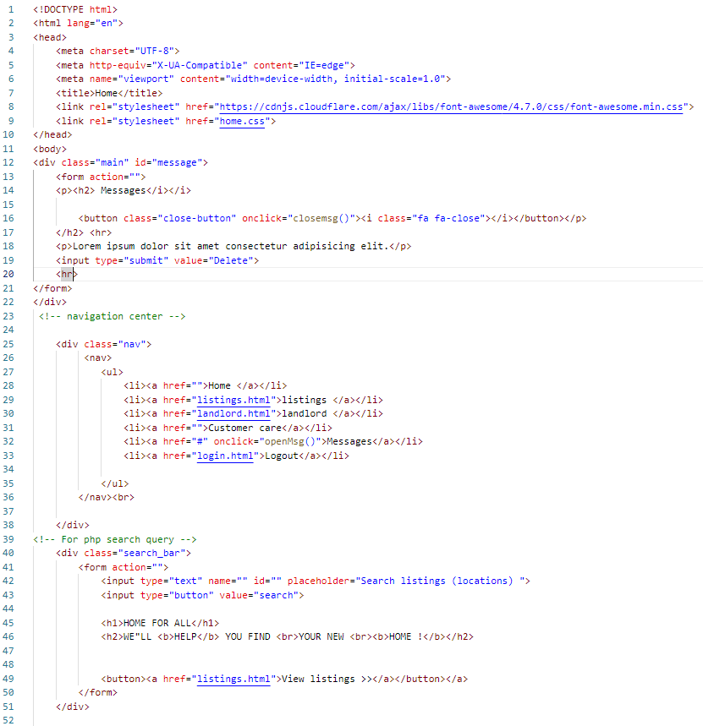

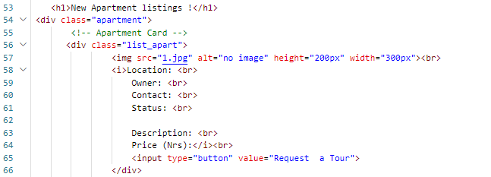 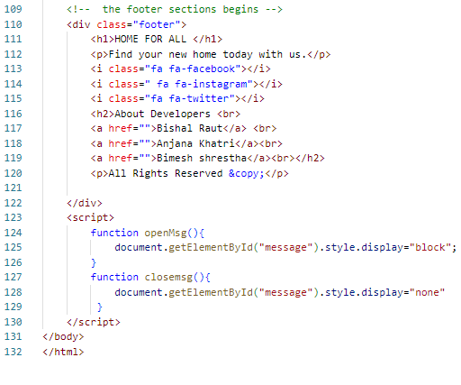

CSS code for home page:

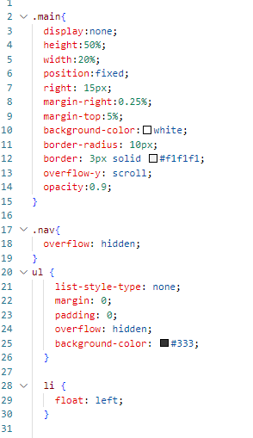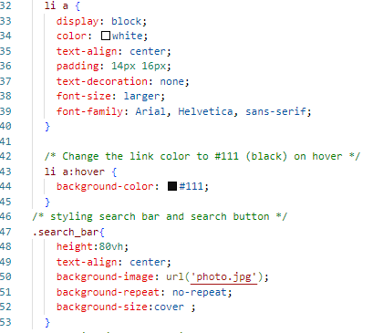

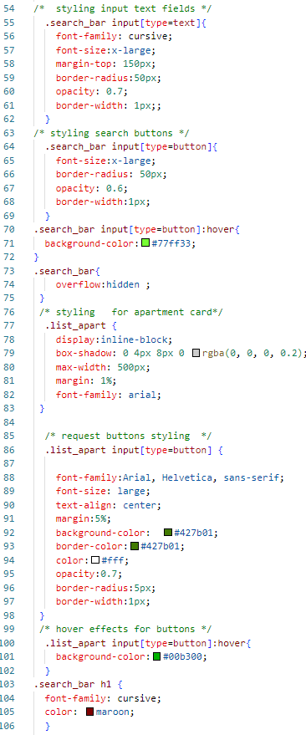 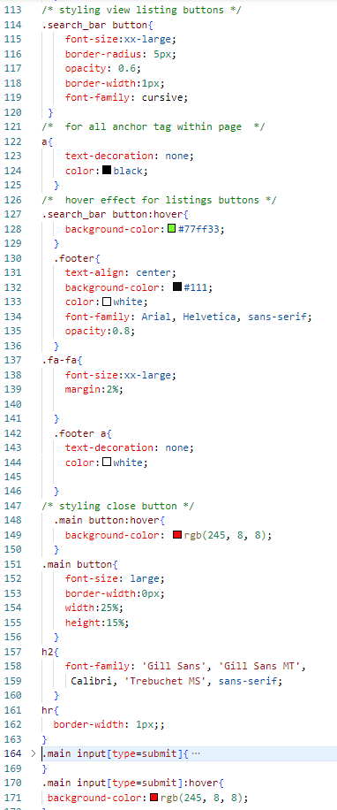

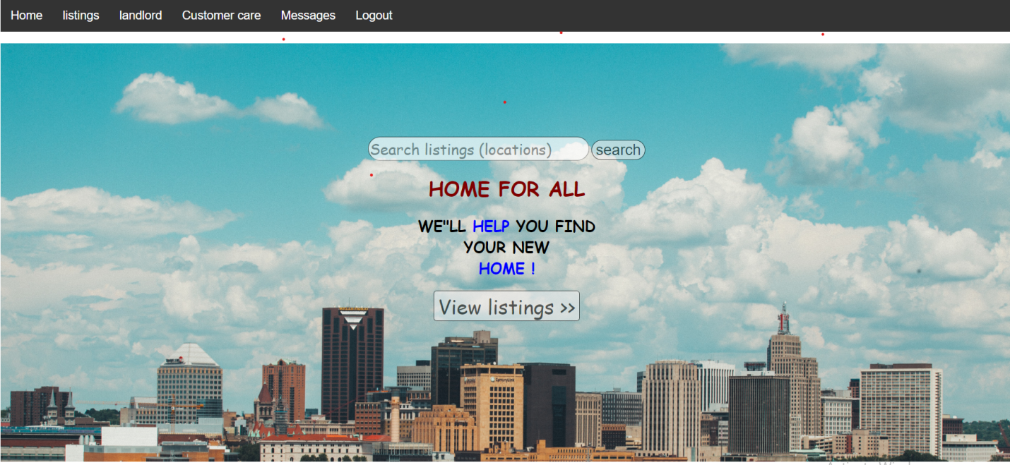

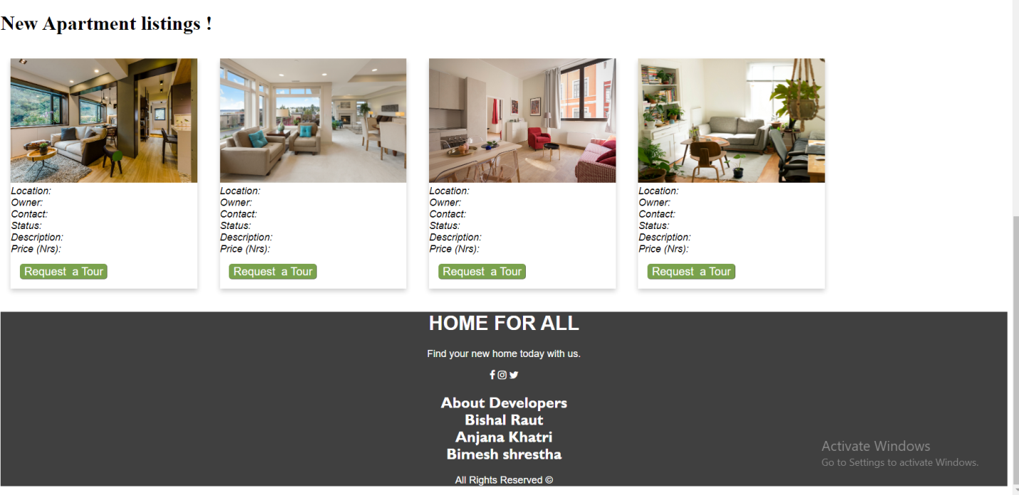

**Landlord page:**

This page contains the information about landlord and status of apartment, cost, location and general description of apartment.

Html code: 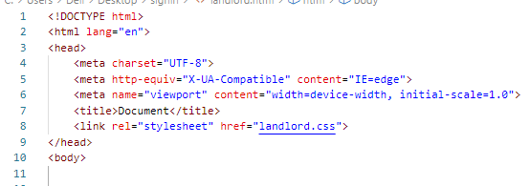 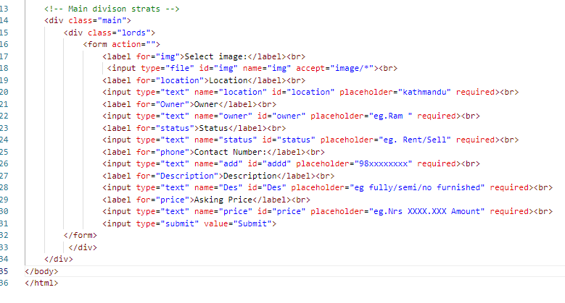CSS code:

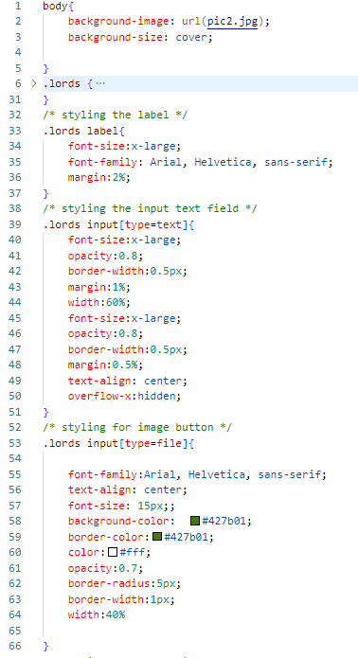 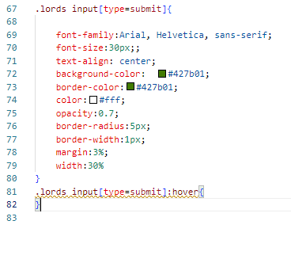

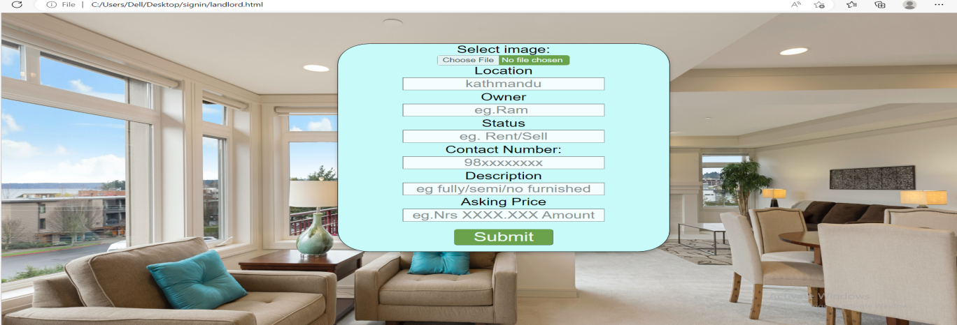

**Listings:**

This page contains all the available general information about apartments and homes in our websites. Renter can request home tour through this page.

Html code:

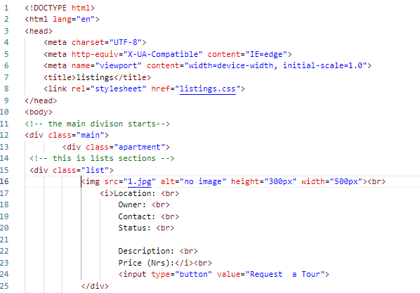

CSS code:

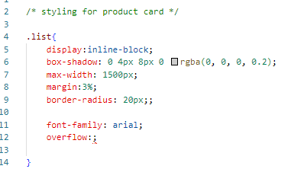 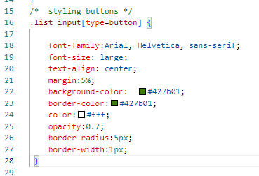

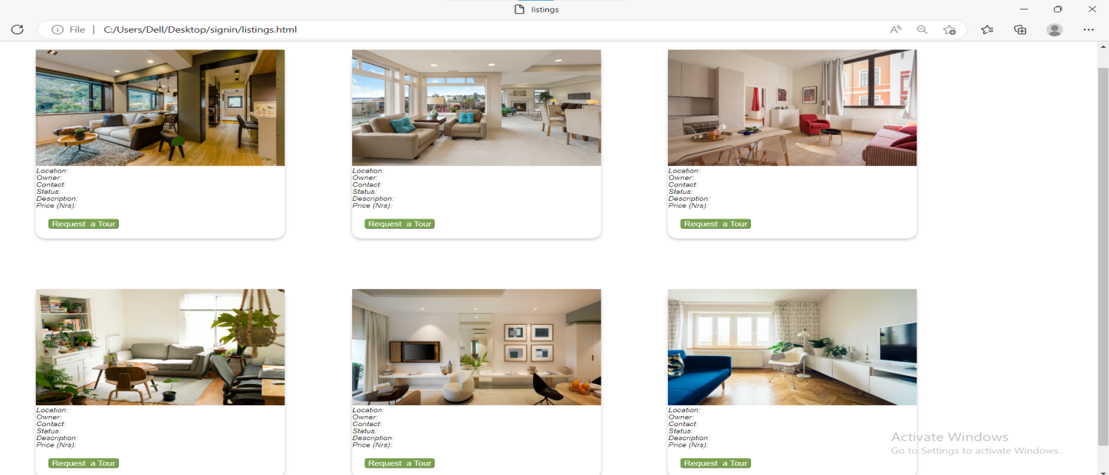**Login and signup page:**

Through this page people can login to our website if they already have account. If you don’t have account you can sign up using signup page.

Html code:

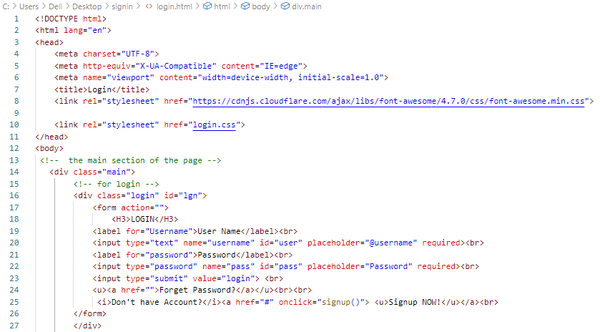

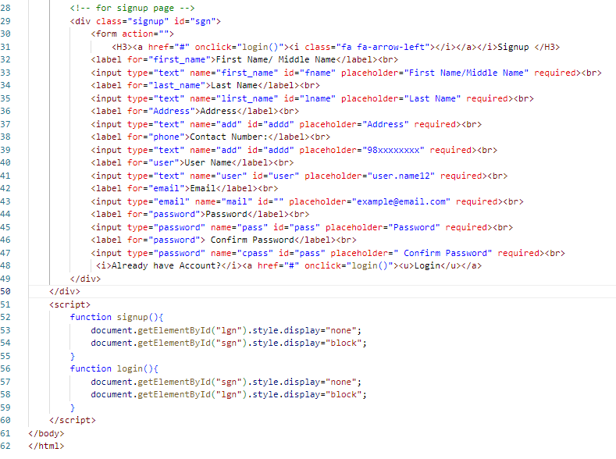

CSS code:

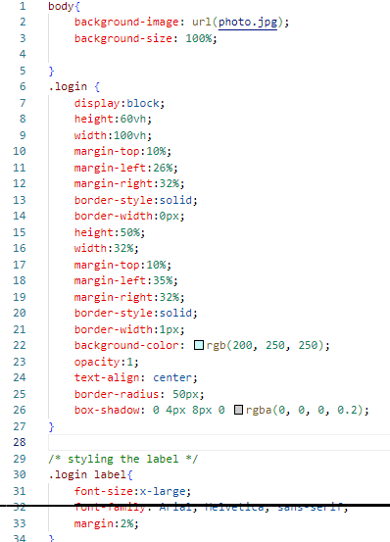 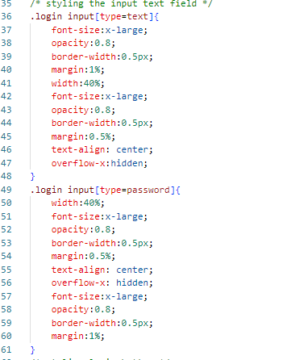

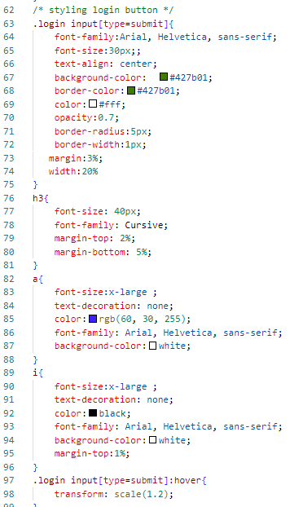 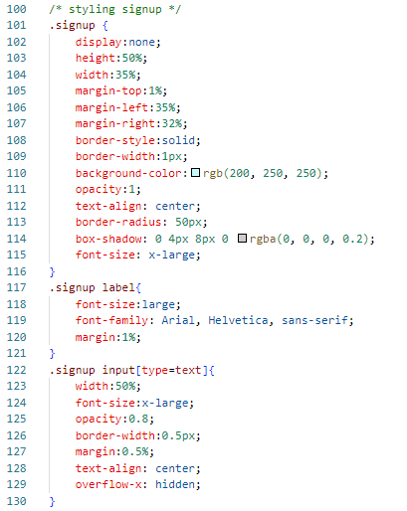

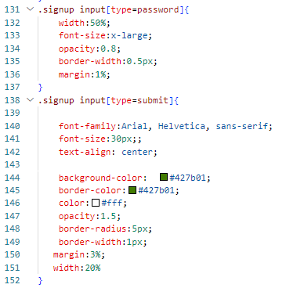 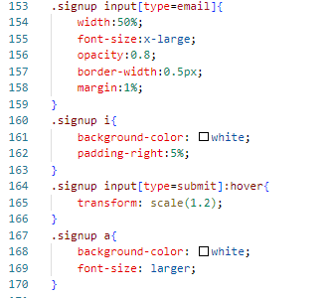

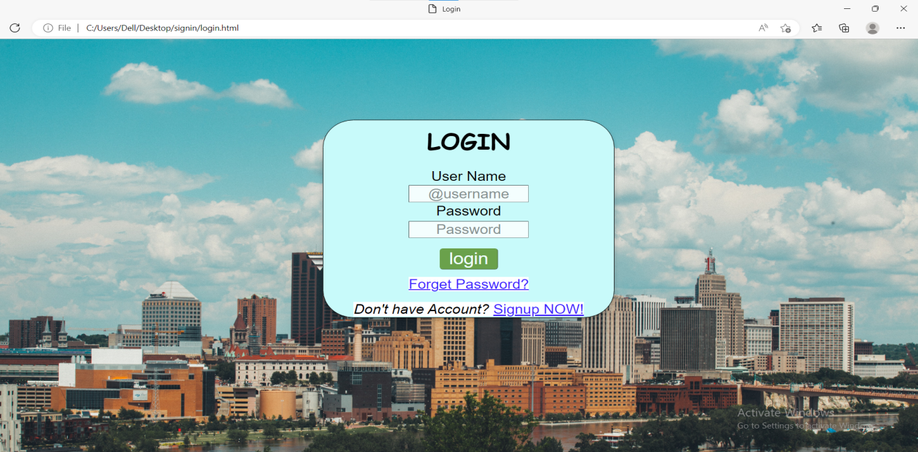

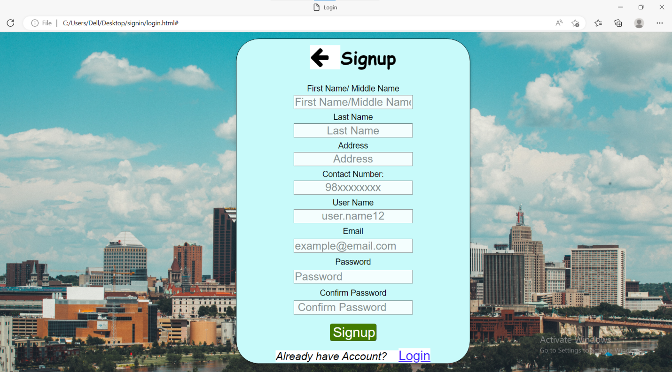

**Dashboard and admin page:**

A website dashboard is an online report where your website data from ecommerce to web analytics is displayed. Admin Pages display in the administration area. Appropriate menus and other styling appear around your content. Use these pages in order to provide extra administration functionality. You can also define admin page modules to be shown when a user is administering your add-on via the Universal Plug in Manager .

**Html code:**

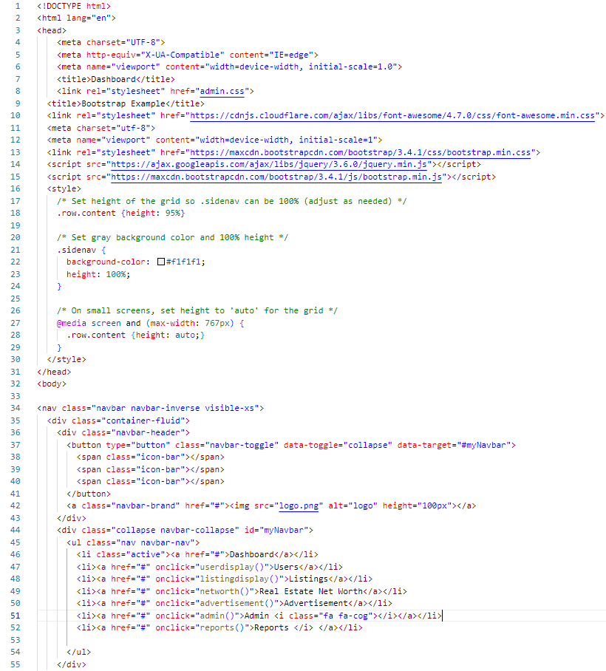

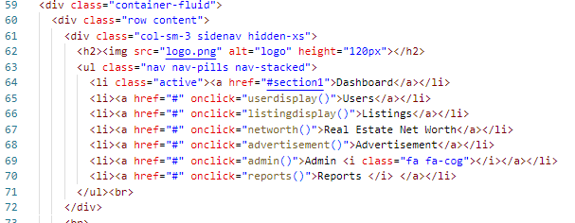

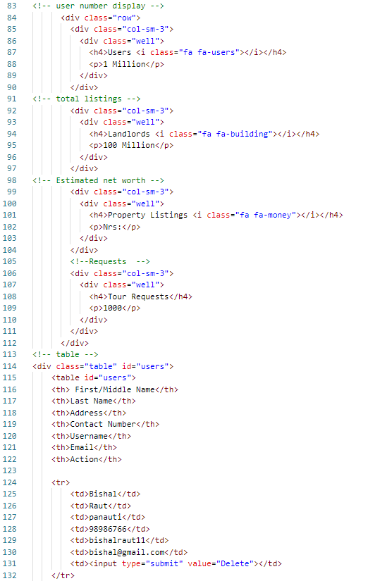 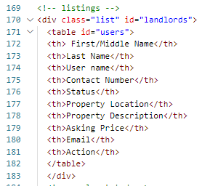

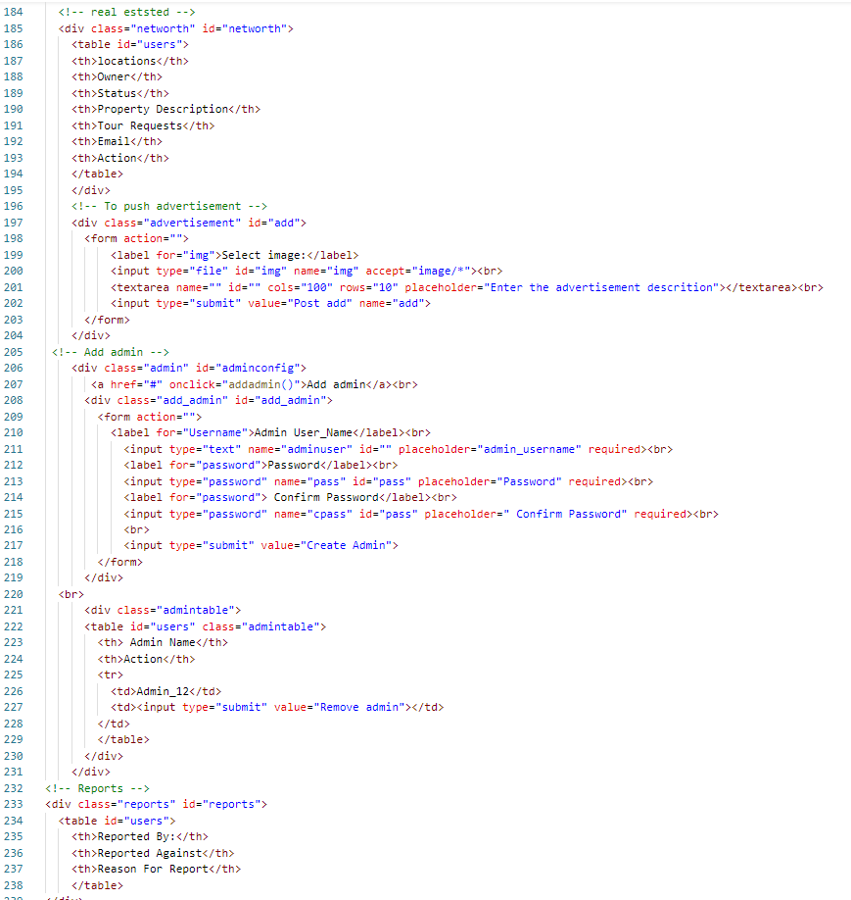

**CSS code**:

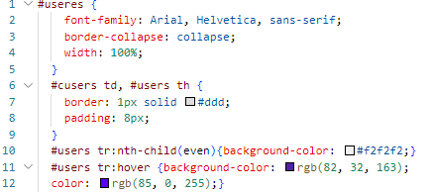 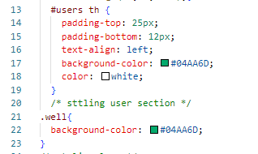

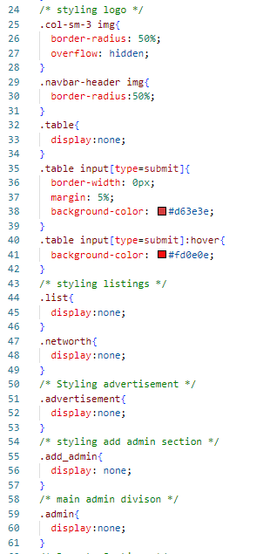 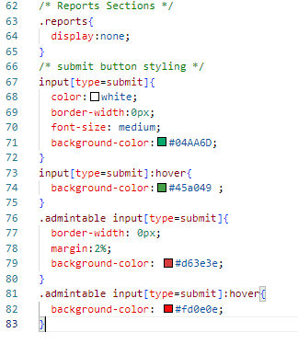

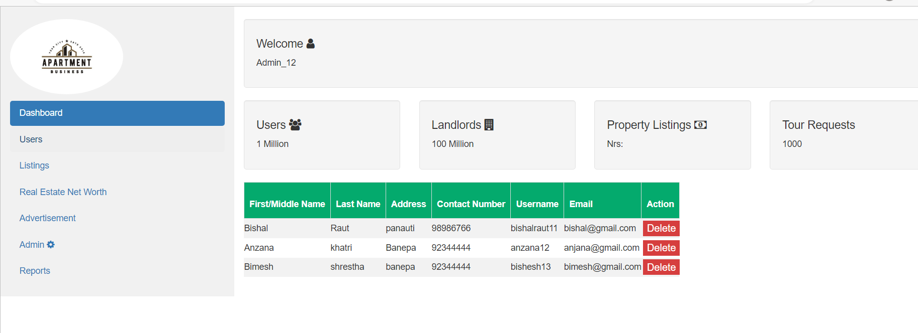

[NOTE: This practical is only about basic html and css, other languages like php and javascript will be added in upcoming practicals.]